**DESCRIPTION**

**ALLENDALE ARM CHAIR**

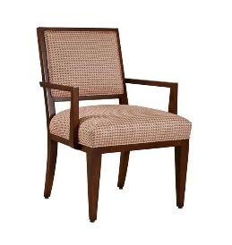

The Allendale arm chair is a variation on our Geneva exposed wood square back chair. This chair features a beautiful fret insert design on the outside back. The geometric circle fret design is delicate in scale having crisp lines and beautiful proportion. The fret part is made from cast resin and is finished to match the chair wood finish. The tightly upholstered back fabric placed behind the fret help to create a stage for the fret design to be clearly seen and appreciated. The inside back of the chair is tightly upholstered with a beautiful welt detail that surrounds the upholstery. The tightly upholstered seat is framed by exposed wood seat rails on all four sides. Tapered leg posts flow down from the exposed wood seat rails to the floor. The arm chair features exposed wood arms that are clean and sleek.

**ASHTRON ARM CHAIR**

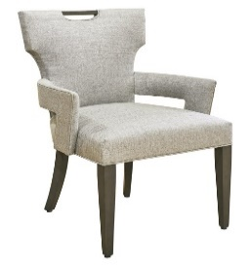

Our Ashton chair features the klismos style, which dates back to the 5th Century B.C. This new design is retro modern having a thinly upholstered back with a very distinctive klismos shape. The top back rail is gently curved and is centered by an exposed wood handle. This handle adds an element of beauty to the chair as well as an element of function when moving the chair around the table. The arm chair features upholstered arms that have an opening between the base of the arm and the chair seat. This opening allows for ease of cleaning crumbs out of the seat when needed. The seat is tightly upholstered. Straight tapered front legs and gently curved back legs are made in exposed maple wood available in any of our wood finishes.

**BEL AIR ARM CHAIR**

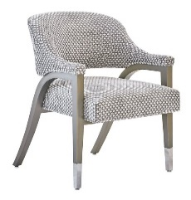

The Bel Air arm chair is modern in style with design elements of Art Nouveau style. The chair has a beautiful balance between exposed wood and soft upholstery. The upholstered curved back flows into the upholstered arms that attaches to the exposed wood arm underneath. The back appears to float over the upholstered seat that is cradled between the exposed wood leg parts and attached to wood cross stretchers. The graceful arch of the chair back is mimicked in the sweeping back legs. The tapered front legs feature tall tapered metal ferrules available in both Polished Stainless Steel and Bronze metal finishes.

**BROCKTON ARM CHAIR**

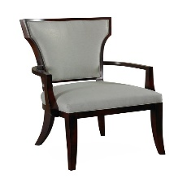

The Brockton chair is a beautiful chair featuring a klismos design element that dates back to the 5th century. Exposed wood frames the chair back upholstery on all four sides on both the front and the back of the chair. An inset welt detail accentuates the shape along the inside wood line. The chair back is open at the back of the tightly upholstered seat. Exposed wood seat rails frame the upholstered seat. The exposed wood front and back leg posts are gently flared. The exposed wood arms are transitional in style.

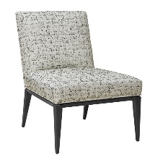**BARNWELL SIDE CHAIR**

Our Barnwell metal base side is sophisticated in style having a simply tailored upholstered to chair part that attaches to an intricate metal base. The base recesses underneath the chair base creating an illusion of the chair floating over the metal base. The metal base has beautifully scaled tapered legs and is finished in Oil Rubbed Bronze, Antique Silver and Antique Bronze finishes.

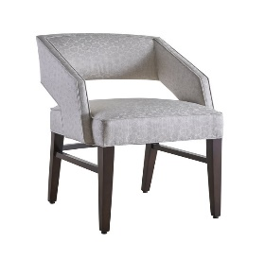**BRANTLEY SIDE CHAIR**

The Brantley chair is a modern open barrel back dining chair with exquisite upholstery details. The arms and gently curved back are accentuated with a top border that is welted both inside and out. The opening between the chair back and seat give the appearance that the back is floating over the seat. Looking at the tightly upholstered seat, note it is bordered on all sides and framed with welt on the top and the bottom. The back of the seat has the same gentle curve as the chair back. Another unique detail to the Jasper chair is the rear tapered legs are chamfered at the outer side so as to keep the flow of the gentle curve of the seat. Straight tapered front legs complete this beautiful modern chair

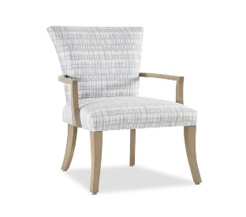**DANBURY VERNADA ARM CHAIR**

For over 30 years, Designmaster has made the best dining chairs and dining stools for interior residential dining rooms. Now we offer our same style, comfort, and quality in our outdoor room collection. Our Veranda Dining Collection features some of our best-selling residential styles with the addition of unique construction and materials to withstand indirect exposure to the outdoor elements.

**SAXTON SIDE CHAIR**

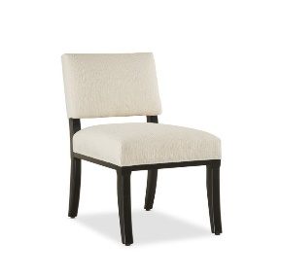

The Saxton Studio chair has the same style elements as the full scale chair having exposed wood seat rails, and radius shaped leg posts. In viewing the chair’s side profile, you see the same wedge shaped upper back and the slightly curved top rail. Even though the Saxton studio is smaller in scale, it is not smaller in comfort. Our studio chairs have the same seat depth as our standard scaled chairs, and the back pitch is also the same. Whether you need the studio chairs for a better fit in a smaller dining space or you need them in order to fit more chairs around a table, you and your guest will be comfortable sharing meals together.

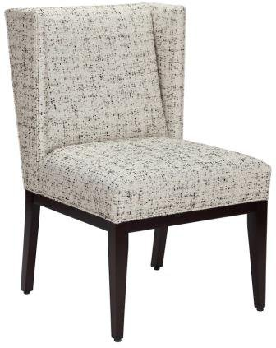**CARSON SIDE CHAIR**

Clean-lined and modern in style, these words describe our new Carson winged side chair. This chair features the same angular wing panels that are on our Carson host chairs. The seat and back are tightly upholstered. Exposed wood seat rails are visible below the upholstery on all sides. Straight tapered front leg posts and gently splayed straight back leg posts complete this new chair style.

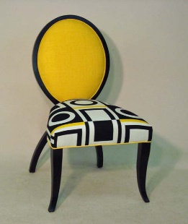**CHARLOTTE SIDE CHAIR**

The Charlotte side chair is a beautiful chair having an exposed wood back that is in the shape of a graceful, crossed ribbon. As you look at this chair, your eyes follow the exposed wood of the back as it flows from the floor up through the crossed area at the base of the seat, around the upholstered back and down through the crossed area again and down to the floor on the opposite side. The serpentine shaped seat draws your eyes from the front of the seat back to the oval shaped chair back. Delicate front leg posts with turned out toe complete the elegant styling of the Charlotte dining chair.

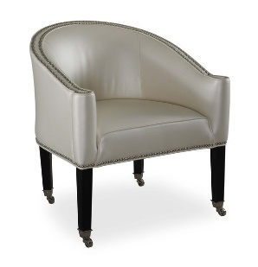**COMPTON ARM CHAIR**

Metro modern with elements of mid-century styling are words that describe the Compton chair. The upholstery and welt detail accentuate the beautiful shape and clean lines of the frame. Tapered legs flow into standard antique brass cap casters. Polished nickel casters are available at no additional charge. The Compton chair is also available with our other casters.

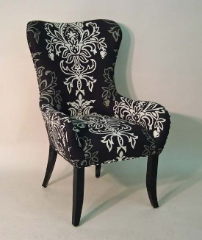

**DENMARK ARM CHAIR**

Inspiration for this Metropolitan lifestyle arm chair came from the famous Egg chair design of Arne Jacobsen from the mid-twentieth century. You will not find many straight lines on our Denmark arm chair. This curvaceous dining chair is sensual and graceful. The slight con-caved chair back features broad curved wings. The curved lines of the arm chair flow from the top of the chair, around the wings, down into a narrow waist and out the arms. A continuation of this line leads your eye down to the beautiful front saber leg posts and to the floor.

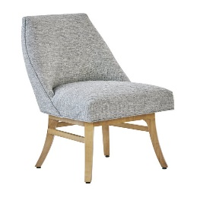**CONTEMPO SIDE CHAIR**

The Contempo side chair is modern in style and functional in being a swivel chair. The seat has a modern sling back shape, having a barrel back and tightly upholstered seat. The seat part attaches to the wood base by memory swivel. The Contempo chairs' exposed wood base is transitional in style with flared, tapered legs and stretchers.

**DILLON SIDE CHAIR**

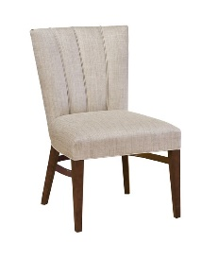

Art Deco in style, our Dillon chair is beautiful and comfortable. Our Dillon chair has a 4-facet back with each facet accentuated with small, vertical welt on both the inside and outside back of the chair. These equally sized facets taper from the top of the chair back down to the tightly upholstered seat on the front and to the seat rail on the back. The slight curve of the seat side rails softens the lines of the chair giving it a modern flare. Straight tapered legs, light in scale, complete this new chair.

**GREENVILE ARM CHAIR**

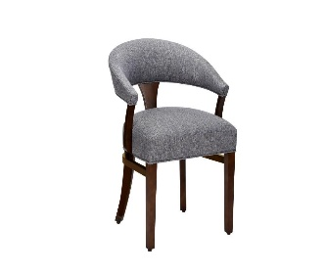

The Greenville Barrel Back arm chair was developed due to the requests to match the Greenville dining stool. This chair has the same edgy interpretation of a traditional Captain’s chair as the stool. Let your eyes follow the chair back from the front of the arm and around through the beautiful arch of the back then continue around to the opposite arm. The rounded barrel-shaped back is positioned at just the right height to support your back as you sit in the chair. The upholstered back is supported in the center by an exposed wood, flared back splat, and exposed wood arm stumps on each side.

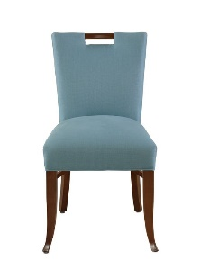**WESTMORELAND SIDE CHAIR**

The Westmoreland Studio side features the same elements as its standard size counterpart. An exposed wood handle centers the softly curved top rail. The wedge-shaped back tapers to meet the tightly upholstered seat. Delicately scaled saber shaped front legs post and gently curved back leg posts support the seat. Transitional and Sophisticated! Available with straight tapered front leg posts as shown on the side chair.